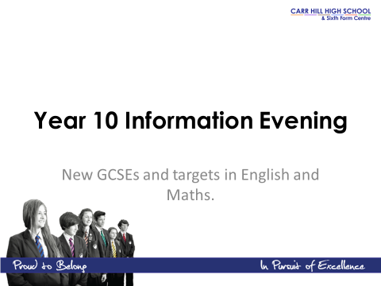

English at Carr Hill High School - How you can help

Students will be studying AQA GCSE English language and English Literature:
http://www.aqa.org.uk/subjects/english/gcse/english-language-8700
http://www.aqa.org.uk/subjects/english/gcse/english-literature-8702
Reading
It helps to encourage your child to read a variety of fiction and non-fiction texts:
Non–Fiction Texts include - newspaper reports, magazine articles, web articles, travel writing, autobiography / biography, leaflets.
Fiction - students can borrow novels and stories from the library in the HUB.
We will be studying the following set texts:
- ‘A Christmas Carol’ – Puffin, ISBN 9780141324524
- ‘Macbeth’ – Oxford School Shakespeare, ISBN 9780198324003
- ‘Animal Farm’ – Penguin, 9780141036137
- Poems from the AQA Poetry anthology – Power and Conflict unit

In school, students will be issued with copies of these texts. Should you wish to purchase them so that your child can complete additional revision at home, it would be useful for these to be the same editions of the texts. In addition, copies of the texts will be placed on our virtual learning environment, Moodle.
Students will list key quotations in the back of their books – regularly learning key quotations is an important skill to help them to support answers.

Writing
The new English Language GCSE will have a greater focus on writing in clear and accurate Standard English. There will be an increased emphasis on spelling, punctuation and grammar including the use of vocabulary.

It helps to encourage your child to proof their work carefully and to correct errors. Spellings should be checked using a dictionary. Key spellings can be written in the spelling page at the back of their books and there are spelling pages in planners. Students use the following colour pens: blue or black for classwork and homework, red for self or peer assessment and purple for response to feedback. Please encourage your child to respond to feedback and improve work in purple pen.

Homework is set twice a week. You can support your child by checking his or her planner and discussing English work. It helps if students have a quiet area to do their work. The library and computing facilities in the HUB are available at lunchtimes and after school.

Additional revision is useful – students should read through their work and check understanding. Revision techniques include colour-coding, completing example plans and answers, recording themselves reading key quotations and making flash cards, mind maps and posters.

Useful resources:
Carr Hill High School - Moodle
Bitesize

Do contact your child’s English teacher if you have any questions during the course.
Mathematics New GCSE Specification 2015
Support
Lunch Time Drop-in Sessions – Every Tuesday and Thursday
Online Support Resources
Examples of login details for Isaac Newton
Maths Watch Kerboodle MyMaths
Centre ID: carrhill Username: inewton Username: carr
Username: inewton Password: inewton (for first login) Password: isosceles
Password: numbers Centre: cw3
Moodle
Further resources and sample papers will be developed and put on Moodle as they become available.

Exam Structure for Higher and Foundation Tier
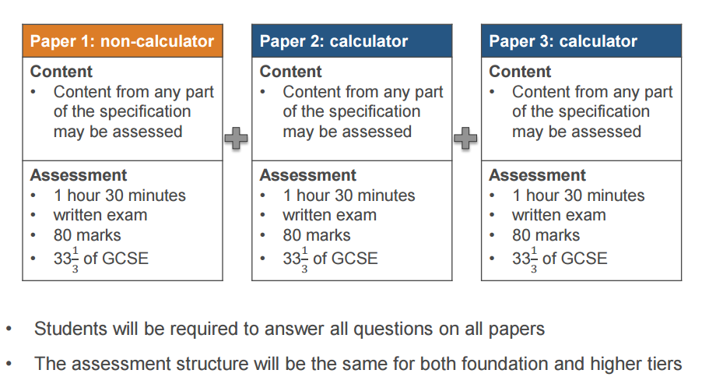
Foundation Tier Grades 1-5 Higher Tier Grades 4 - 9

Order Form
Higher
New MathsBuster: GCSE Maths Interactive Revision (Grade 9-1 Course) Higher - Online Edition £6.00
New MathsBuster: GCSE Maths Interactive Revision (Grade 9-1 Course) Higher - DVD Edition £6.00
New MathsBuster: GCSE Maths Mock exam Paper Book (Grade 9-1 Course) Higher £2.50
New GCSE Maths Revision Guide: Higher - for the Grade 9-1 Course (with Online Edition) £3.00
New GCSE Maths Workbooks: Higher - for the Grade 9-1 Course (with Online Edition) £3.00
Foundation
New MathsBuster: GCSE Maths Interactive Revision (Grade 9-1 Course) Foundation - Online Edition £6.00
New MathsBuster: GCSE Maths Interactive Revision (Grade 9-1 Course) Foundation - DVD Edition £6.00
New MathsBuster: GCSE Maths Mock exam Paper Book (Grade 9-1 Course) Foundation £2.50
New GCSE Maths Revision Guide: Foundation - for the Grade 9-1 Course (with Online Edition) £3.00
New GCSE Maths Revision Guide: Foundation - for the Grade 9-1 Course (with Online Edition) £3.00
Order by 30th September 2015
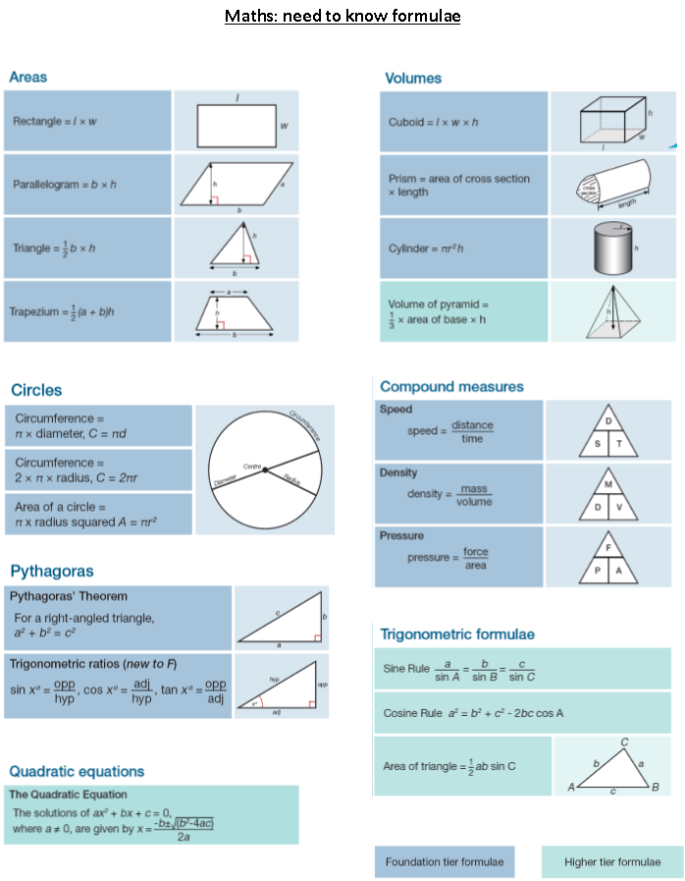

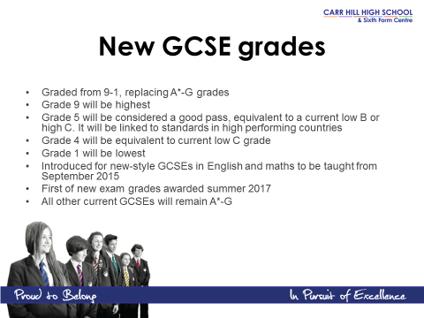

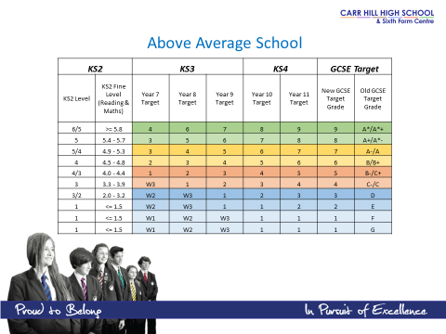
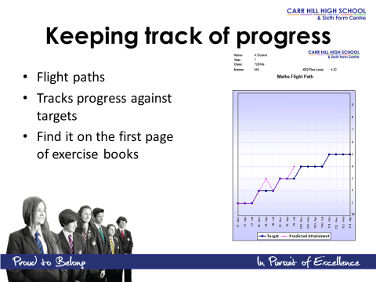

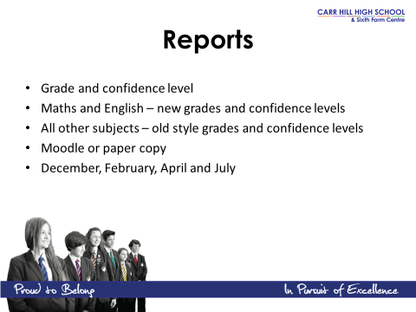

NOTES
