Application Form
for
Student Sports Council Leadership Roles
(Sports Captain, Vice-Sports Captain)

Student Sports Council Leadership at Carr Hill High School & Sixth Form Centre
Student sports leadership is strong at Carr Hill High School & Sixth Form Centre, and a formal structure of student sport representatives exists to ensure that student voice is effective, and ideas are acted upon by the PE department. The diagram below show the structure of the Sports Council at the school:
Sports Council:
Made up of:
7 X female Sports Captains
7 X male Sports Captains

Each College has 2 representatives on the Sports Council.
The Sixth Form also has two representatives.
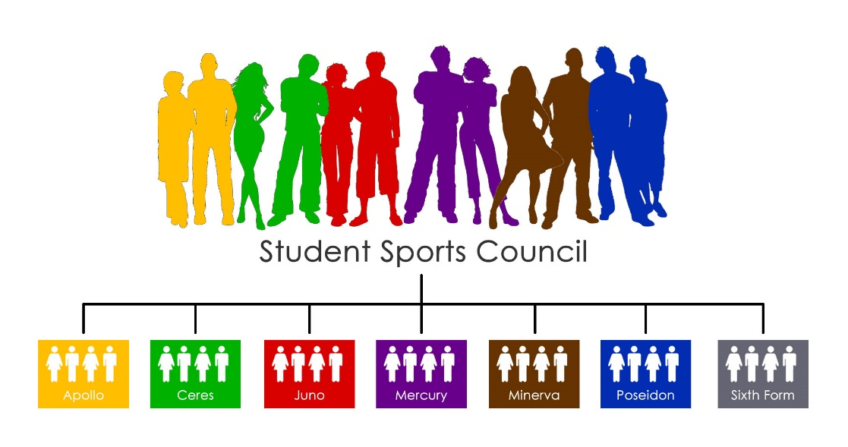
Vice-Sports Captains

7 X female Vice-Sports Captains
7 X male Vice-Sports Captains

Each College has 2 Vice-Sports Captains.

Student Sports Leaders
Student sports leaders are appointed for a 12-month term, and are selected through an application and interview process. The Sports Captains and Vice-Sports Captains need to have qualities that will enable them to fulfil the demands of their roles. A student sports leader will:
- Be able to use their initiative;
- Show commitment to the school, their college and their leadership role;
- Be reliable and have good time management skills;
- Demonstrate good organisation skills (personal and the ability to work in teams);
- Be determined and persevere to achieve success;
- Show humility (the role represents the College and School, but at the same time it represents a service to the other students);
- Act with responsibility;
- Demonstrate leadership;

Appointment process
If you wish to be considered for a student sports leadership role, you must submit a completed application form to Mr Doughty. Applicants who have submitted an application will be shortlisted and invited to interview. Appointments will be announced thereafter.

The Sports Council
The Sports Council shadow the School Sport Co-ordinator and play a vital role in the raising the profile of school sport. There are two Sports Captains in every College and two Sports Captains in the Sixth Form (14 total), who are all members of the Sports Council and represent the sporting views of their College. The Sports Council are also responsible for organising regular inter-college competitions in a variety of sports and activities for all age groups, as well as making pupils aware of sporting opportunities in the local community. The Sports Council will meet once a half term to organise events and discuss new initiatives.

The Sports Captains
The appointed Sports Captains for each College will play a role in the organisation and leadership of sport in their College. There will be two representatives of the Sports Council in each College (2 x Sports Captains). They will be integral of collecting the sporting views of their College and feeding this back to the Council.

The Vice-Sports Captains
The appointed Vice-Sports Captains for each College will play an important role in assisting the Sports Captain in the organisation and leadership of sport in their College. There will be two Vice-Sports Captains in each college, one female and one male.
 | SECTION 1 | Information about you...
 | Student Name |  |  | Mentor Group

 | SECTION 2 | Tell me which post(s) you want to apply for...
 | Sports Captain Post | () |  | Vice-Sports Captain Post | ()
 | Sports Captain  2 post per college (1 female/1 male) |  |  | Vice-Sports Captain  2 post per college (1 female/1 male)

SECTION 3 | Tell me about the contributions you make...
Explain what contributions you have made to sport at Carr Hill High School and/or your Primary School?
Explain what contribution you have made to sport in your local community

SECTION 4 | Tell me why you are applying...
Why do you wish to become a student sports leader?
What skills do you have that will help you be an effective student sports leader?
What would you like to achieve as a student sports leader?

Completed application forms should be submitted to Mr Doughty by 17/06/16

