7th January 2019

Dear Applicant

Thank you for your interest in the position of Science teacher at Carr Hill High School. Our students are well behaved, keen to learn, and make a contribution to school life in the vast majority of cases. Our staff are hard working, talented people who want the best for our students.

In the inspection 12 months ago we were graded as Requires Improvement but that came as no surprise based on KS4 results in recent years. We were fully aware of the key improvement indicators highlighted by Ofsted and were already working on them. The report is very positive on the whole about the Sixth Form but unfortunately, due to financial constraints we have had to make the decision to phase out Post 16 and so 2018-19 will be the final year of Post 16 provision. Science results in 2018 saw major improvement and this should now be sustained with an excellent team of Science staff.

Our mission is based on two principles, in “pursuit of excellence” and “proud to belong”. If you believe you can make a positive contribution to the success of our Science students, especially in Chemistry, then we would be very pleased to hear from you. GCSE courses begin in Year 9 and we currently we follow AQA Triple and Trilogy specifications.

The Science Faculty is headed by Cathy North and if you would like any further information please feel free to contact either Cathy or myself.

Best wishes.

Yours faitfhully

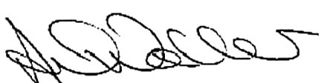

Mr A Waller
Headteacher

