February 6th 2019

Dear Applicant

Thank you for your interest in the position of Music teacher at Carr Hill High School. Our mission is based on two principles, in “pursuit of excellence” and “proud to belong”. Our students are well behaved, keen to learn, and make a contribution to school life in the vast majority of cases. Our staff are hard working, talented people who want the best for all our students.

Carr Hill is located in the town of Kirkham between Blackpool and Preston and has very easy transport links. We are currently an 11-18 High School with just over 1000 students in Years 7-11 and 30 students in Year 13. The Sixth Form will close in 2019.
Ofsted inspected the school in December 2017 for the first time in 5 years and while the ‘Requires improvement’ judgement was disappointing it came as no surprise based on historical results. It was very encouraging however that the inspectors recognised that the visual and performing arts are a strength of the school and we are proud of this.
Music is part of the Performing Arts Faculty along with Drama and Dance. Students in Years 7 and 8 follow a course in all 3 disciplines and we have a small group following the BTEC Music course in GCSE years. If you believe you can make a positive contribution to the success of all our students in Music then we would be very pleased to hear from you.

Best wishes.

Yours faithfully

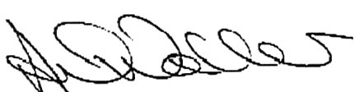

Mr A Waller
Headteacher

