7 March 2019

Dear Applicant

Thank you for your interest in the position of teacher of English at Carr Hill High School. Our mission is based on two principles, in “pursuit of excellence” and “proud to belong”. Our students are well behaved, keen to learn, and make a contribution to school life in the vast majority of cases. Our staff are hard working, talented people who want the best for all our students.

Carr Hill is located in the town of Kirkham between Blackpool and Preston and has very easy transport links. We are currently an 11-18 High School with just over 1000 students in Years 7-11 and 30 students in Year 13. The Sixth Form will close in 2019.
Ofsted inspected the school in December 2017 for the first time in 5 years and while the ‘Requires improvement’ judgement was disappointing it came as no surprise based on historical results. It was encouraging that the inspectors recognised that there is now ‘improved progress across all subjects including English, Mathematics and Science’ and the Inspectors saw evidence of really good teaching in English.
A new Subject Leader in English took up post in September 2018 and you would be joining a team of 8 specialist English teachers. If you believe you can make a positive contribution to the success of all our students in English then we would be very pleased to hear from you.

Best wishes.

Yours faithfully

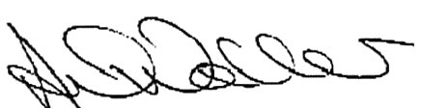

Mr A Waller
Headteacher

