Getting Started with your Chromebook.
Contents
Introduction 2
Getting To Know the Keyboard 2
Some Trackpad Tricks 3
Chrome OS Apps Menu 3
Search the Web 4
Changing Wallpaper 4
Taking Screenshots 4
Screen Lock and Password Protection 5
Connecting to your home WiFi 5
Managing Files 6
Using Office 365 on your Chromebook 8
Email 9
OneDrive 11
Using Home Access Plus+ on your Chromebook 15
Connect your Home Printer to Google Cloud Print 18
Questions 18

Introduction

Chromebooks run Chrome OS which is the Chrome web browser plus a little more. Getting use to Chrome OS will be very easy for Chrome users but, with a little help, this experience can be even more effortless and rewarding.

This Guide will help you make the most out of your new Chromebook from day one. You are already using online services in school such as Office 365 email, OneDrive and Home Access Plus.

Let’s get started…

Getting To Know the Keyboard

The design of your Chromebook is a little different from traditional computers. The first difference that you will notice is the keyboard. Chromebooks do not have a caps lock key. Instead of function keys, you have dedicated keys for managing your Chrome browser. Getting used to this may take a while but once you get the hang of it, I am sure you will enjoy it.

So what do you need to know to make the best out of the Chromebook keyboard?

Here is the first thing for you to do. Press CTRL + ALT + ? and you will see all the available keyboard shortcuts.

The Search Key and Caps Lock Key

The caps lock key has been replaced with a search key. The search key opens the Chrome OS apps menu. Chrome OS Apps Menu is quite useful. Refer to Chrome OS Apps Menu section of this guide for more information. To get the caps lock key back, go to settings and search for Keyboard. From keyboard settings, you can change the function of the search key to caps lock. Personally, I like the search key and when I really need caps lock on, I use the following keyboard shortcut.

ALT + SEARCH

Use this keyboard shortcut to enable or disable caps lock. When caps lock is turned on, you will see an up arrow like icon next to time on the taskbar.

No Delete Key

Yes, there is no delete key on your Chromebooks. Here is the keyboard shortcut you will use.

ALT + Backspace - Delete the next letter (forward delete)
CTRL + Backspace - Delete the previous word

No Home or End Keys

Alternate keyboard shortcuts are;
Home - ALT + Up Arrow key
End - ALT + Down Arrow key
Dedicated Brower Keys

We talked a lot about things that you won’t see on a Chromebook. Now let’s talk about things you get extra on your Chromebook’s keyboard.

Instead of function keys (F1 to F12, remember?) Chromebook gives you dedicated browser keys, or keys that you can use to perform some actions that you do on the browser. The following is a list of dedicated browser keys that you get.

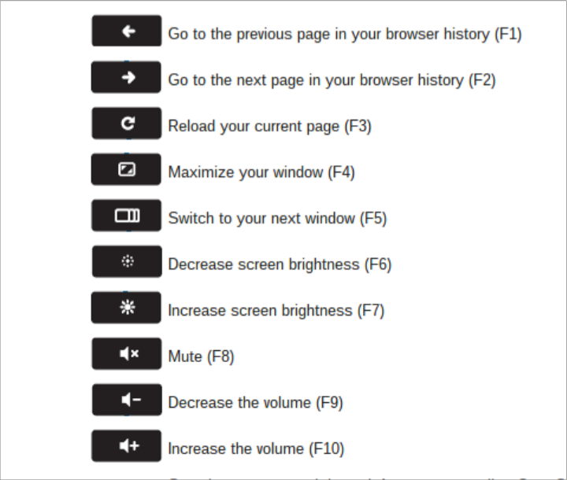

Some Trackpad Tricks

1. Click or tap with two fingers for right click
2. Swipe with two fingers for scrolling

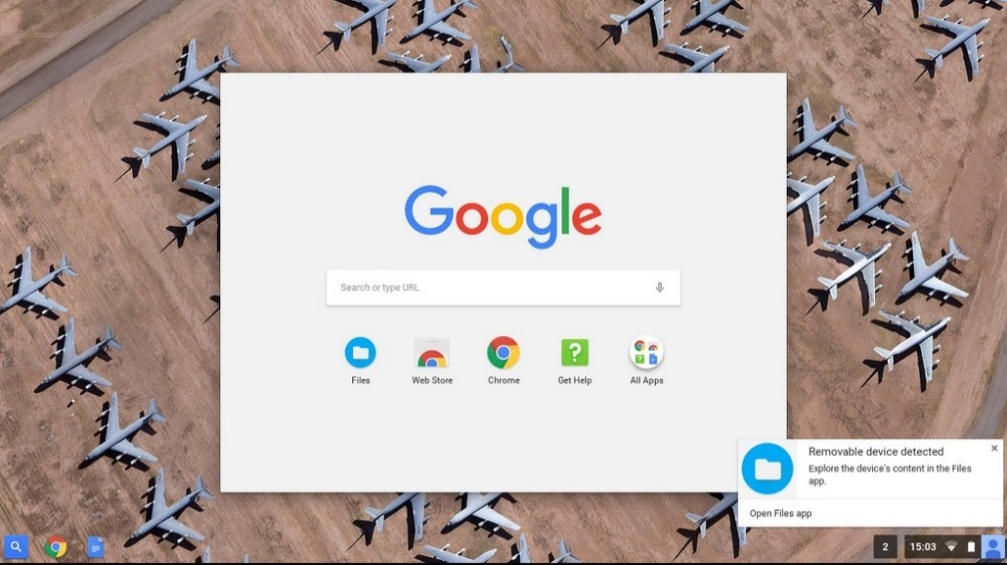
Chrome OS Apps Menu

For starters, the Chrome OS Apps Menu is similar to the start menu on Windows. You can open the apps menu by clicking the apps icon on the taskbar or pressing the Search key.

From the Apps Menu, you can:
Launch apps we have installed from Chrome Web Store into carhillschool.com: Click the app icon from the menu, and the app will launch on a new tab. Right click the app icon for more options like, adding the app to the taskbar, or the launcher as they call it. You can right click any app to remove it from your Chromebook.

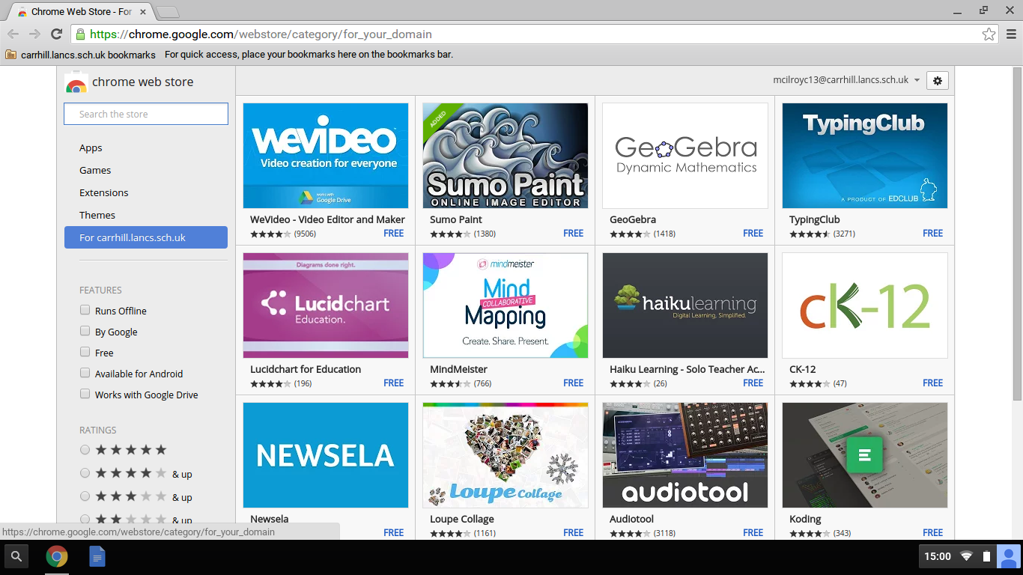

Search the Web

You don’t need to open a new tab, open Google.com and then type in the search query. You are on a Chromebook now! Press the search key once to open the Chrome OS apps menu, type in your query and hit Enter. A new tab will open with your search results.

Changing Wallpaper

Just like your PC, right click the desktop and choose Set Wallpaper. You can pick wallpapers available there or use your own image.

Taking Screenshots
Ctrl + takes screenshot of your current window.

Ctrl + Shift + gives you more control. Use this to take a partial screenshot by selecting the area you want to capture.

Screen Lock and Password Protection

To lock the Chrome OS screen, click the profile icon on the taskbar (or any of those icons there on the bottom right corner!) and click the lock symbol.
Or even better, press CTRL + SHIFT + L to lock the screen. Most of the time, instead of using this method, I tend to close the lid of the Chromebook and walk away. When I open it again, I open the lid and I am ready to go, instantly. But there is one thing that I don’t like here. If I keep my Chromebook closed and move away from it, anyone else can open it up and start using it. You should have your Chromebook ask for your password when I open the lid again, for a little more security.

Here is how to do this: Go to settings and search for sleep and select require password to wake from sleep next to your profile.

Connecting to your home WiFi

You can connect your Chromebook to your home WiFi when you are not in School.

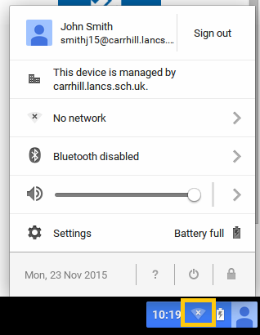
1. In the bottom left corner click the disconnected WiFi icon.

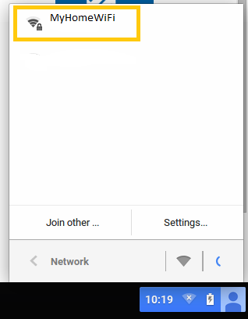

2. Click your home WiFi name.

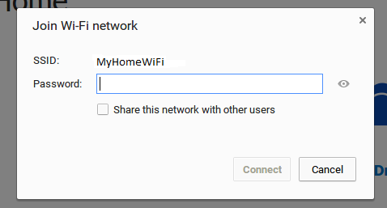
3. Enter the password for your home WiFi and click Connect.

Managing Files

The Chromebook has a 16GB of storage which can be used for downloading files. This is quite a small amount as the Chromebook will primarily use web services such as Office 365.

You can access your files by clicking the search icon in the bottom left corner.

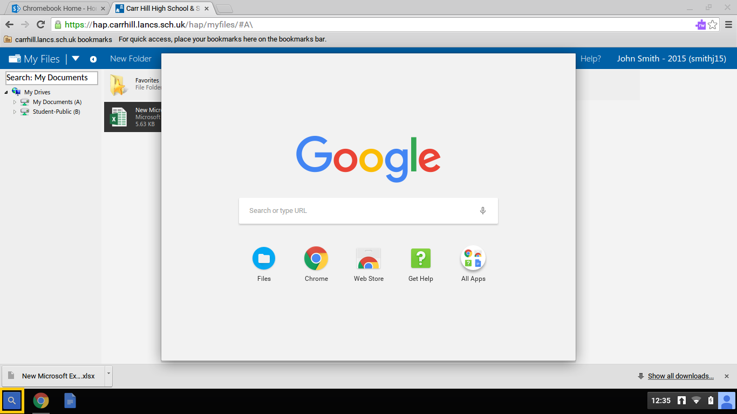

Click Files.

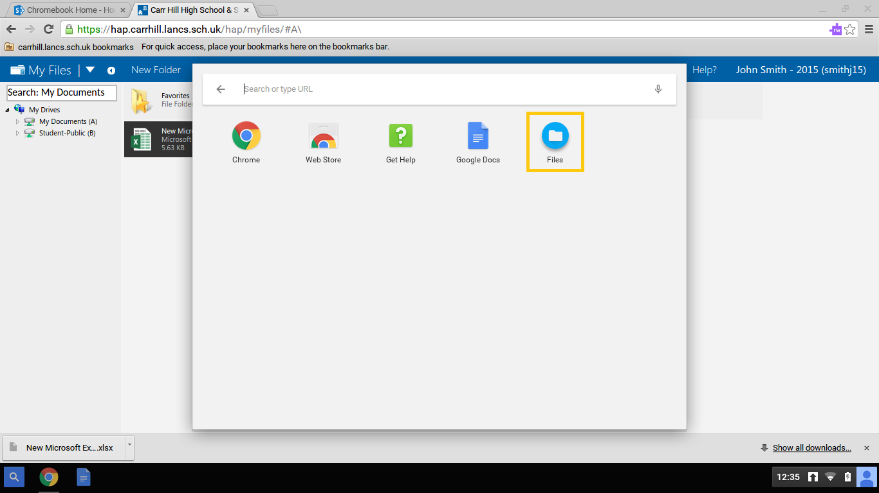

Your downloaded files will be saved here. Ensure you delete any un-used files as you only have a small amount of storage on your Chromebook. Files should be uploaded to your OneDrive storage area after being downloaded in order to work on them (see page 14 for more information).

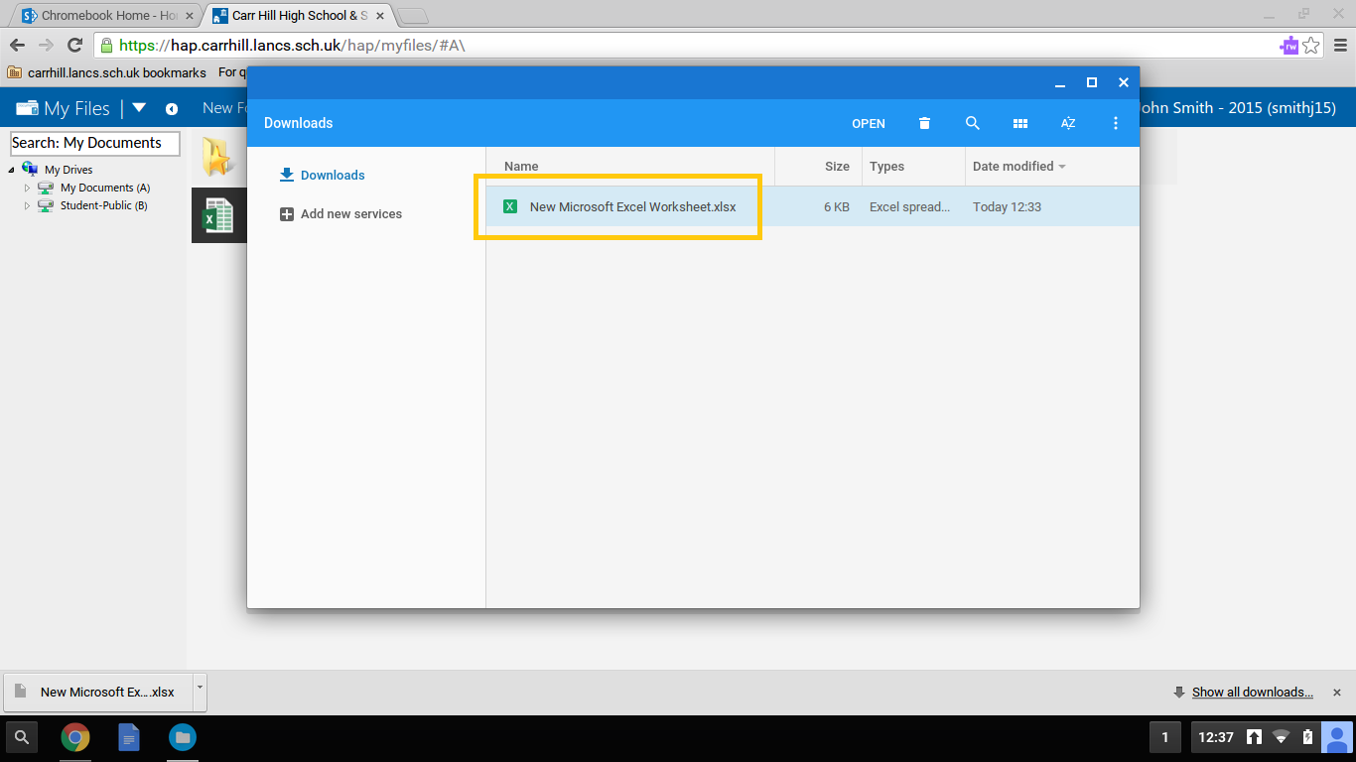

Using Office 365 on your Chromebook

It is the Schools intention to use Office 365 primarily when using your Chromebook. Office 365 includes Email, OneDrive and online versions of Word, Excel and PowerPoint. All your work will be saved automatically to your OneDrive storage area.

When you first login to your Chromebook the Office 365 page will open.

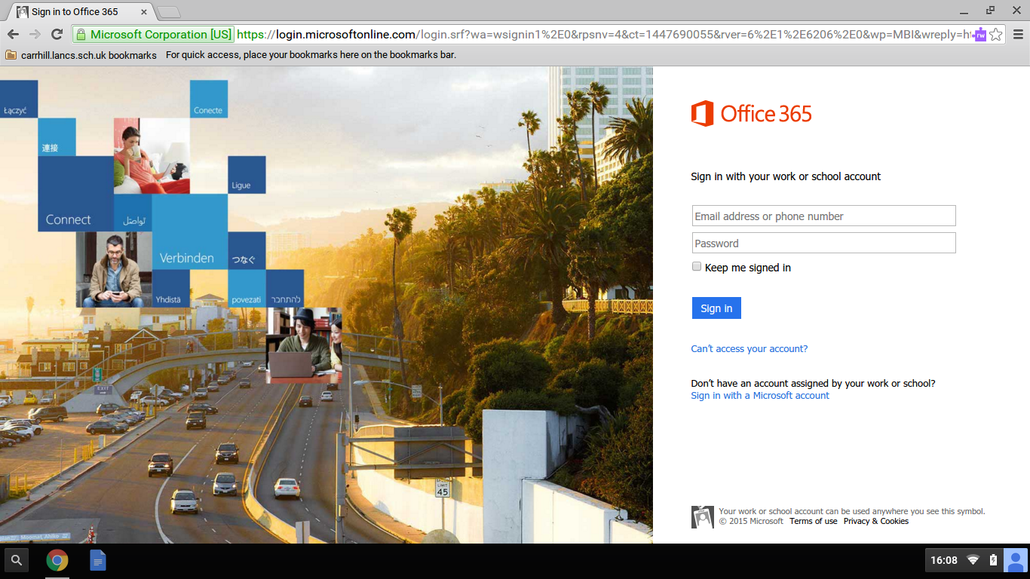

Login with your email address and password. A special ‘Chromebook Home’ page will open giving you quick access to Office 365 apps as well as Home Access Plus, Moodle and other links.

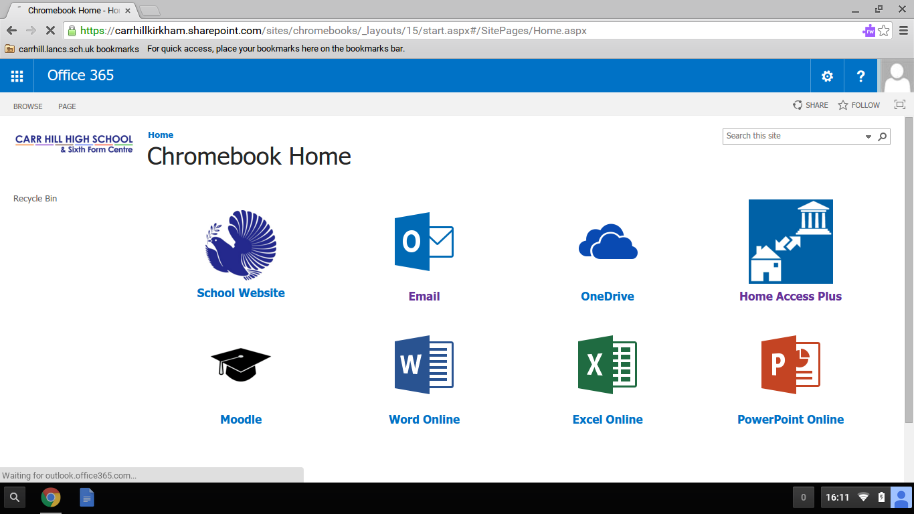

.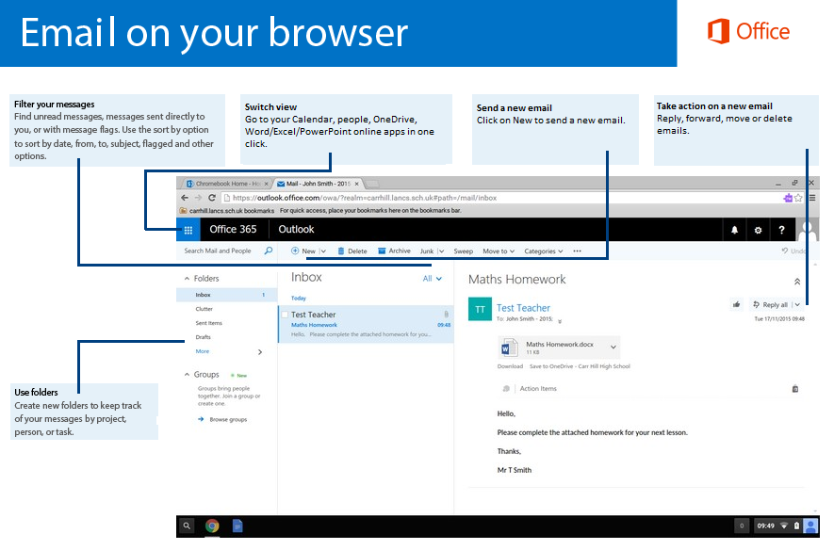
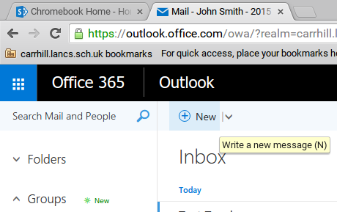
Create a new Email

- Click on New to create a new email.
- In the email, add recipients, a subject, and type the email. Ensure your email is clear and polite.
- Click Send.

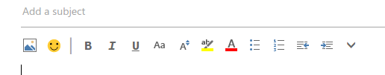
Change the format of your text

To change the font, size, colour, and format of the text in your email, you can select them from the format ribbon in your email.

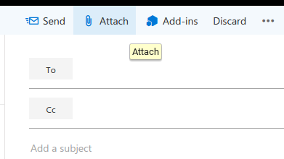
Attach a file

To attach a file to your email, select Attach on a new email. You can select a file saved in your OneDrive or your Chromebook.

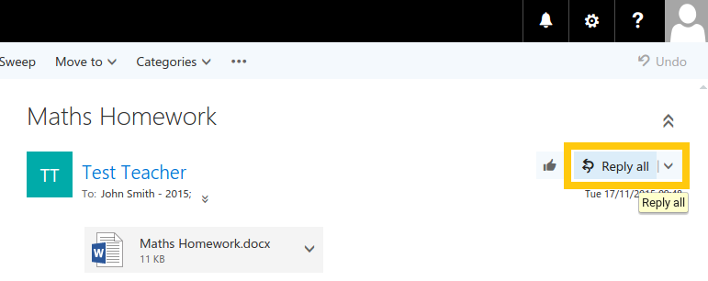
Replying to an email

When replying to an email the default setting is Reply all. This is not always the correct way to reply to an email.

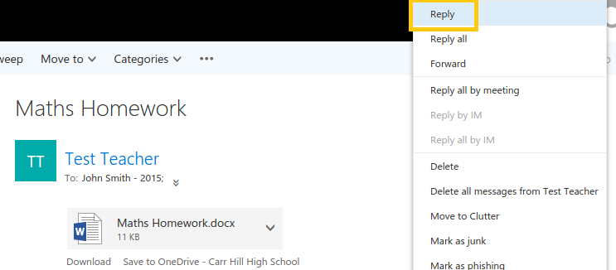

We recommend clicking on the drop down arrow next to Reply all and clicking Reply. This will allow you to reply to the sender of the email rather than all recipients included in the original email. We recommend only using the Reply all option if the email warrants a reply to all.

.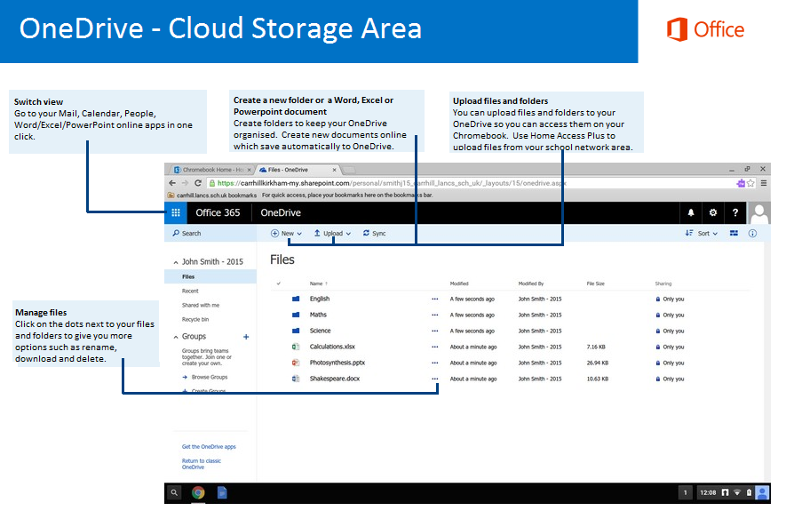

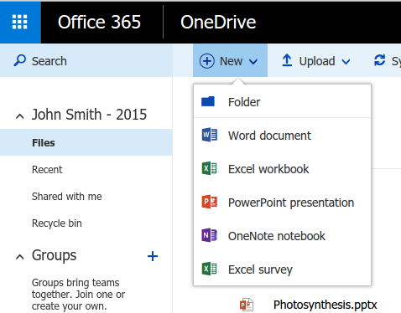
Create a new folder or a Word, Excel or PowerPoint document

You can create new folders to keep your files organised. You can also create a new Word, Excel or PowerPoint Document which will then open on the Chromebook and save automatically to your OneDrive.

The picture below shows a Word online document open. You can create Office online documents with the majority of the functionality that you would find when using Office on a school PC. Note, there is some functionality that is not available in Office online however Microsoft are frequently updating the service to bring new functionality.

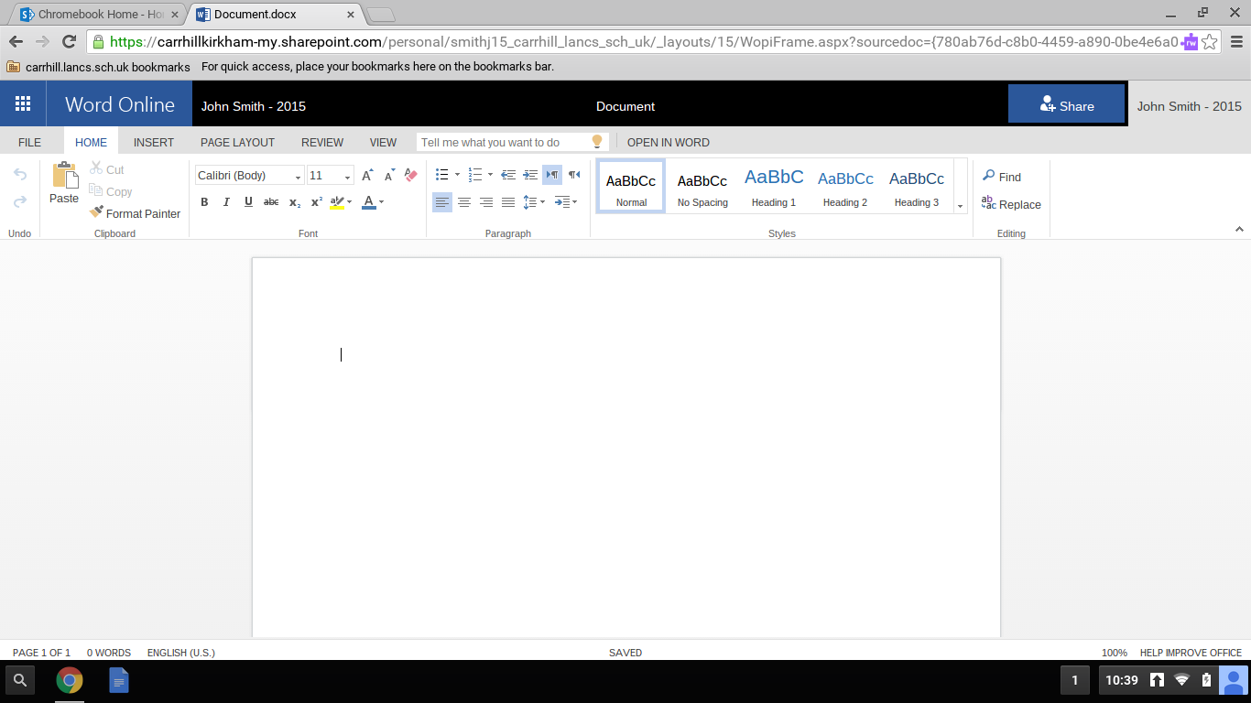

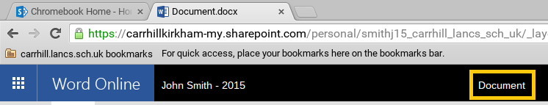
You can rename your document to give it a descriptive name. Click on the area that says Document and type a new name.

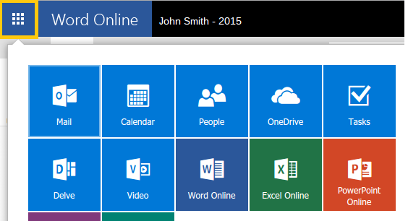
When you are finished working on your document you can return to OneDrive by clicking the icon in the top left corner and then click OneDrive.

Documents saved in your OneDrive can be opened again by clicking on them.

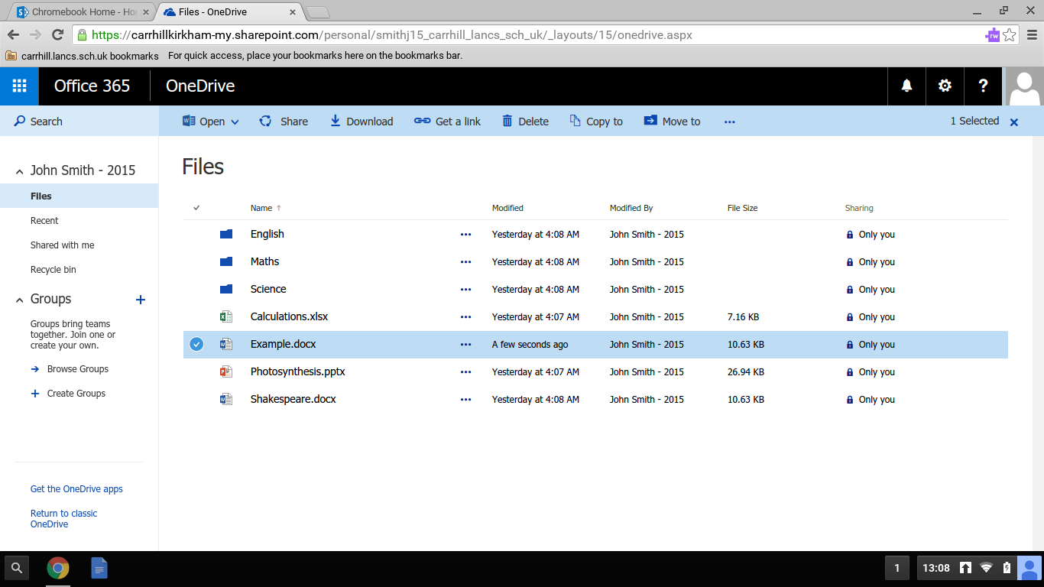

Upload files and folders

You can upload files and folders to your OneDrive that are saved on your Chromebook or USB device. You can also upload files saved in your school My Documents area via Home Access Plus (see page 15 for more information).

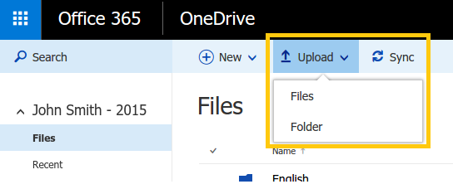
To upload a file or folder:

- Click Upload and click Files or Folder.

- The file window below appears.
- Select the file or folder you want to upload and click OPEN. If you connect a USB device it will be shown on the left.
- The file or folder will then be uploaded to OneDrive.

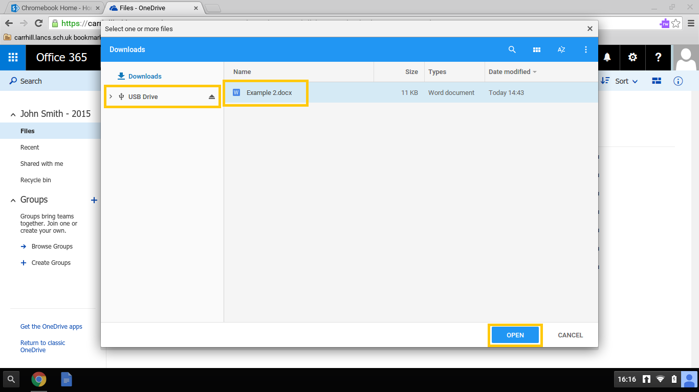

Using Home Access Plus+ on your Chromebook

Home Access Plus+ (HAP+) allows students to access their School My Documents area from a Chromebook.

- At the login page enter your School username and password and click login. You do not need to type your full email address.

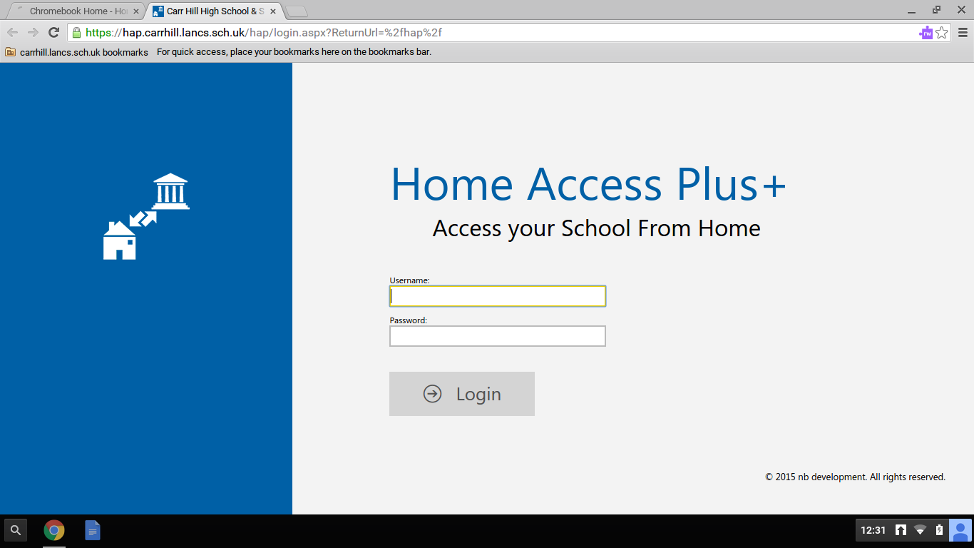

- On the Resources page you have 4 icons:

Me to view your account information and reset your password.
Files to access your My Documents area.
Email to login to your Email.
Moodle to login to Moodle.

Next, click the Files icon.

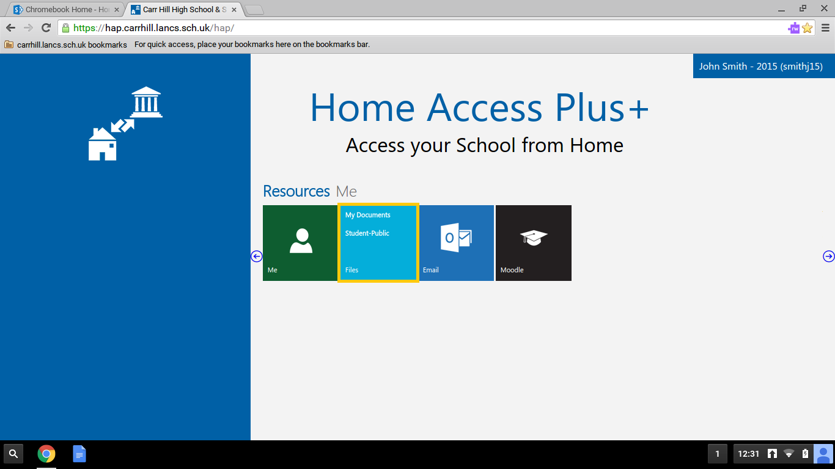

- On the My Files page you can access your My Documents area and the Student-public area. Click on My Documents.

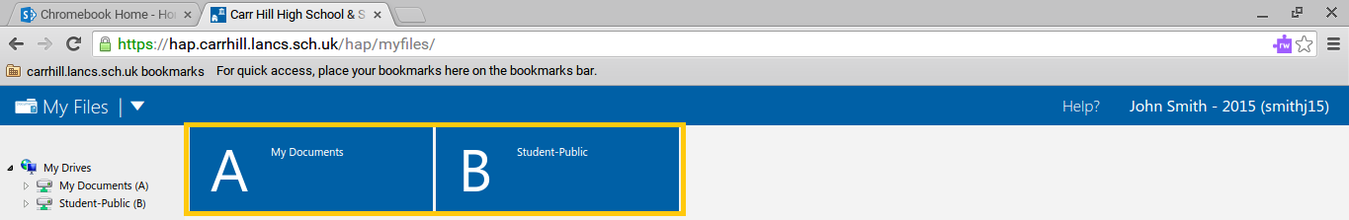

- Your My Documents area will be displayed allowing you to access your files and folders. The key difference to accessing your files with HAP+ is that you need to download and upload files. On the Chromebook you will need to download files and then upload it to your OneDrive.

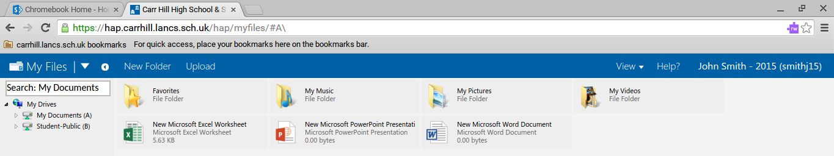

- Single clicking files will bring up additional options at the top. Select a file and click Download.

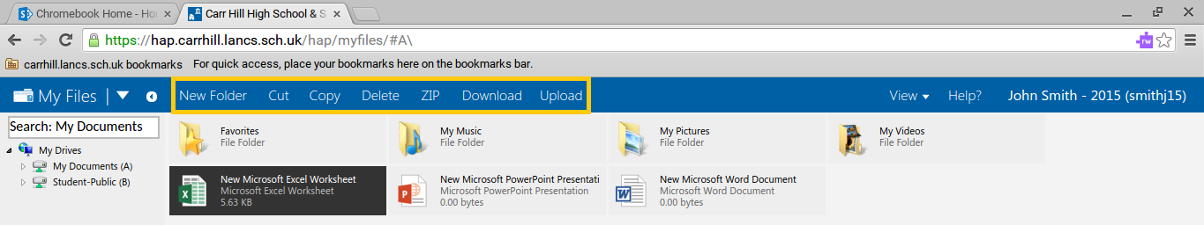

- A message will appear like below. Click OK.

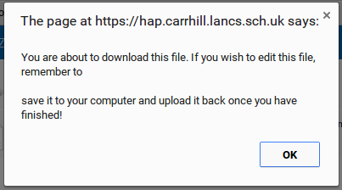

- The file will then be downloaded to the Chromebook. Ensure that you now upload this file to your OneDrive in order to work on it (see page 14 for more information).

Connect your Home Printer to Google Cloud Print

In order to print using the Google Cloud Print service, first connect your printer to the service. Google Cloud Print can print to either a Cloud Ready printer that can connect directly to the Internet or a classic printer that is plugged into a Windows or Mac computer with Internet access. If you are using a Chromebook and you attempt to print, you will be prompted to set up Google Cloud Print to connect a printer.

Using your Chromebook at school? You will be connected to the same printer you use on the School PC’s -Whole School Printing. This will be setup on the day you got your Chromebook, which will be available when you're signed in to your school email account.

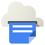 Connect a Cloud Ready printer

If your printer is Cloud Ready, follow your manufacturer's provided instructions.

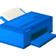 Connect a classic printer

To connect your classic printer, enable the Google Cloud Print connector, using a Windows or Mac computer that's connected to the printer. You'll need Google Chrome to be installed on the computer. If you're using Windows XP, make sure that you also have the Microsoft XML paper specification pack installed, which can be downloaded here. Once Google Chrome is installed, follow the steps below to enable the Google Cloud Print connector in Google Chrome.

1. Turn your printer on.
2. Log in to your user account on the Windows or Mac computer.
3. Open Google Chrome.
4. Click the Chrome menu on the browser toolbar.
5. Select Settings.
6. Click Show advanced settings.
7. Scroll down to the “Google Cloud Print” section. Click Add printers.
8. If prompted, sign in with your Google Account. This will be your school email address and password, which you login to your Chromebook with.
9. Select the printers you want to connect and then click Add printer(s).

The printer is now associated with your Google Account and connected to Google Cloud Print. You can print to this printer whenever you’re signed in with the same Google Account on your Chromebook.

Questions

Is there anything else that you are trying to figure out on your Chromebook? Come see IT Services in the HUB or send us an email at it_support@carrhill.lancs.sch.uk and we will try to answer your question.

